TECHNICAL EXHIBIT 4 (TE 4) — KTA MAP BUILDINGS
Kahuku Training Area (KTA), Island of Oahu, HI. This exhibit provides building identification and site maps in support of PWS place of performance (2.2.3.1) and the equipment inventory in TE 1. Buildings covered under this PWS:
• Building 15 (CAC01) — Fire alarm & mass notification (EST-3), seven (7) Trane central AHUs, lightning protection (SSMR shared with CAC02), emergency lighting & exit signs.
• Building 17 (CAC02) — Installation Storage (RPSUID 5677). Two (2) LG packaged terminal AC units (RAC-1, RAC-2), lightning protection (shared SSMR), emergency lighting & exit signs. Physical inventory worksheet and maps below.
• Building 100 — Two (2) Mitsubishi 5-ton ductless split AC units; emergency lighting & exit signs (if installed); confirm lightning protection during initial inventory (PWS 8.12).
Access: Coordinate entrance to KTA with Range Control Operations Center, Building 1150, Schofield Barracks, Hawaii. Cell: (808) 853-0440. Water is not available at this remote location (PWS 2.2.3.3 / 2.2.3.4).

Physical Inventory (Minimum Data) Worksheet — Building 17 (CAC02)
RD/Installation: US Army Garrison Haw Facility Number: CAC02
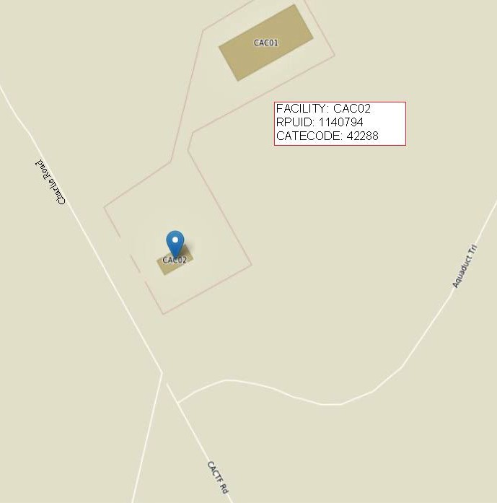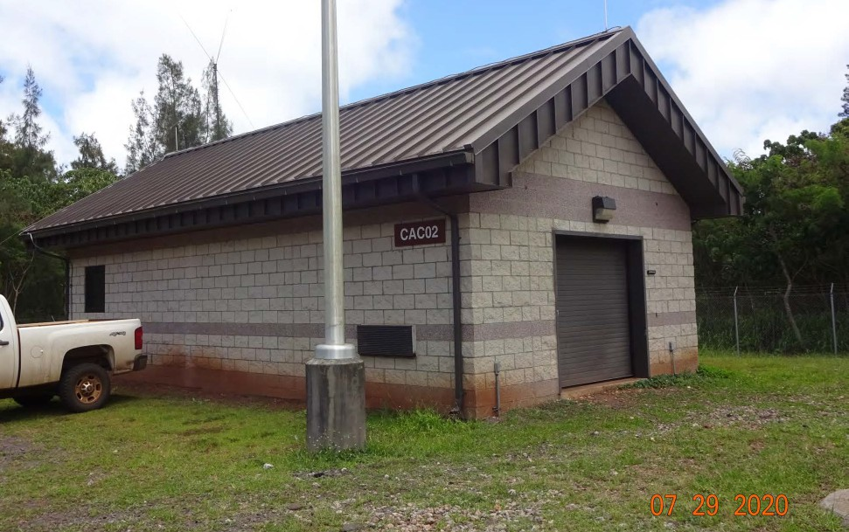
RPSUID: 5677 Facility Name (Name of BU): INSTALLATION STORAGE

